2008 Falcon Horse Camp
EARLY REGISTRATION INFORMATION

Falcon Horse Lover Camp’s popularity continues year after year. Each year Horse Camp fills quickly and each year we have waiting lists.

Several years ago we increased the size of Horse Camp from 8 to ten campers in an effort to accommodate more interested campers. While we believe it worked fine with the amount of instruction and horses necessary to do it right, we also thought it worked even better with the smaller numbers. In 2006 we decreased the size of Horse Camp back to eight campers per week and everything just seemed to flow easier. We will maintain the size at 8 campers again most of this summer. The 7th and 8th weeks will increase to 12 campers as long as there are more horses and instructors available from the traditional camp program. There is not another camp riding program like this anywhere in the Midwest and we like it that way. Horse Lover Camp offers unique benefits for campers in such a small environment. We try to keep tuition reasonable for everyone and the more you keep telling your friends about Horse Camp, the less we need to spend on advertising. Those savings come back to you in keeping tuition lower (Econ 101 to you future college students).

What this means for you: Registering Early becomes more important to insure that you do have a space reserved in the sessions you want. Early Registration will take place from now until December 20. Much of Horse Camp was filled during early registration the past several years. We are anticipating that camp will fill even faster this year.
As a bonus, anyone registering before December 20 will receive a $100 tuition discount. Your tuition will be $800 instead of the $900 tuition for 2008. Registration consists of sending in your application with $200 deposit for each week .

Pick your session and sign up now for a great summer in 2008. If you have any questions, please give us a call.
We would be happy to send information to your friends or send extras for you to post in your barn, stables or anywhere people love horses!
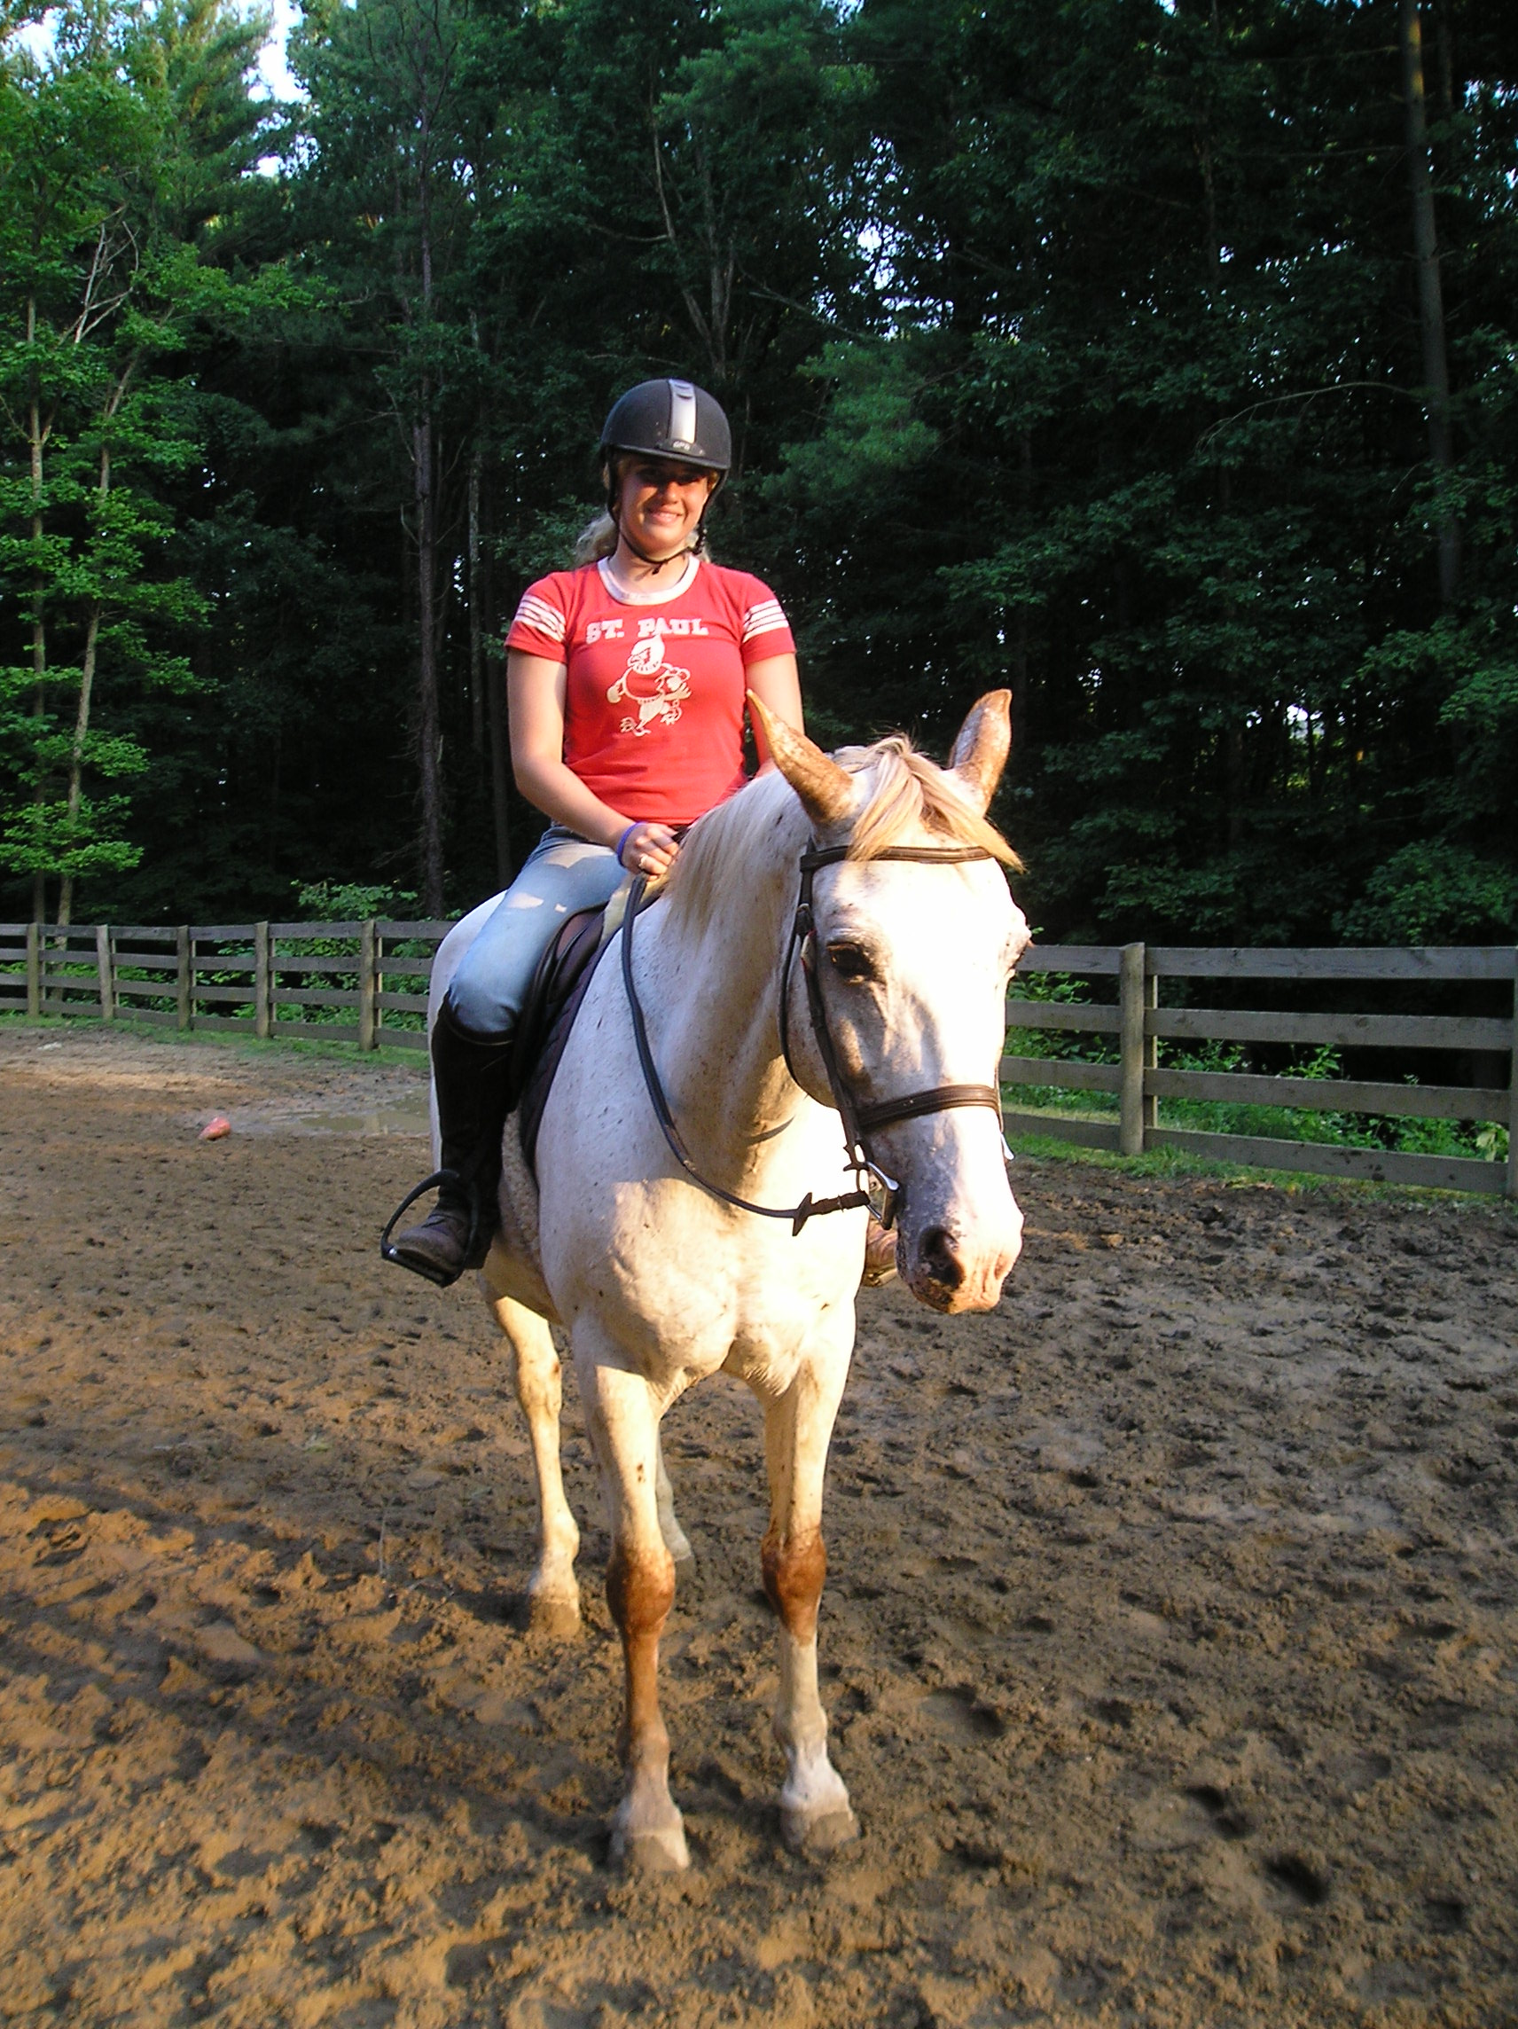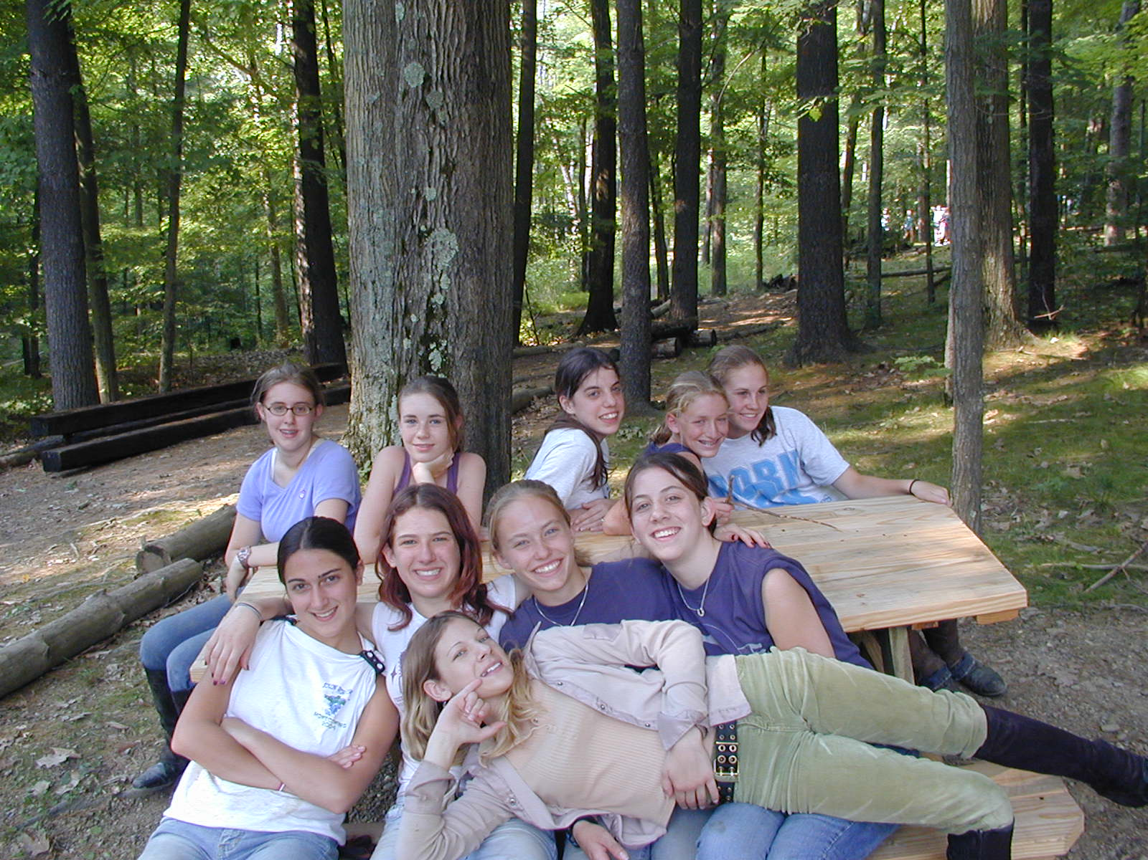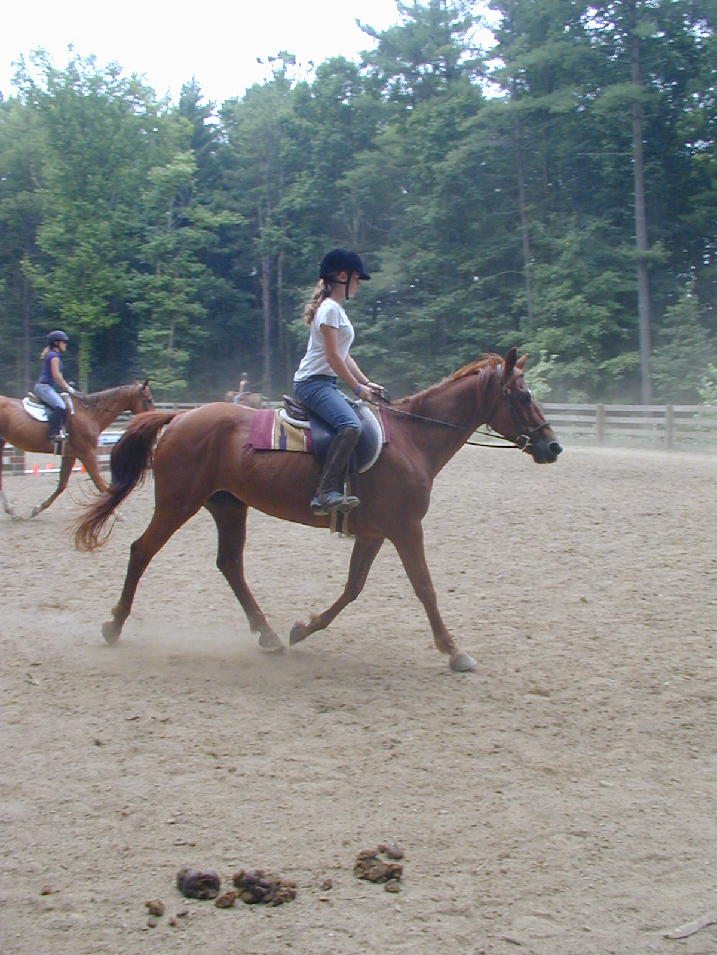

2008 CAMP CALENDER

June 22 – June 28 Girls Only Limited to 8 Campers July 13 – July 19
June 29 – July 5 Girls Only Limited to 8 Campers July 20 - 26
July 6 – July 12 Girls Only Limited to 8 Campers July 27 – August 2

August 3 – August 9 Girls Only Limited to 12 Campers August 10 – August 16

Winter: 22232 Rye Rd. Shaker Hts,OH 44122 phone: 800/837-CAMP or 216/991-2489 Fax:216/991-4908
Summer: 4251 Delta Rd SW. Carrollton, OH 44615 phone: 330/627-4269 fax: 330/627-2220
Email: Office@FalconCamp.com or HorseCamp@FalconCamp.com Website: www.FalconCamp.com

