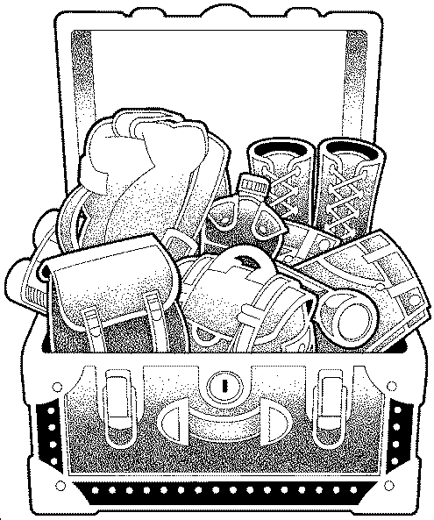

Falcon Clothing and Equipment List
Use this list as a guide for your packing. Clothing should be simple and comfortable. Laundry is done once a week for 4 week or longer campers and once for 2 weekers. All clothing must be clearly labeled. There is an option to label clothing enclosed in this mailing or choose your own. Falcon will not be responsible for lost items. Attach this to the inside of a trunk or a suitcase. It will assist you in checking items as you pack and assist us in helping campers pack to return home. Please remember to label things like tennis shoes, jackets, and the clothes they wear to camp, etc. We make every effort to have campers return home with everything they brought.

Clothing:
___ 3 Falcon T-shirts (camp dress)
___ 7 other T-shirts
___ 2 sweatshirts (Falcon ones available)
___ 1 poncho or raincoat
___ 6 prs. of shorts
___ 4 prs. of jeans/long pants
___ 2 bathing suits (conservative style only)
___ 10 prs. of underwear
___ 2 prs. of pajamas or sleepwear
___ 12 prs. of socks
___ 2 pr. of tennis shoes
___ 1 pr. of sturdy shoes with a heel
(for riding and hiking)
___ 1 pr. of beach or shower shoes
___ 1 medium weight jacket

Optional Items:
___ simple fishing gear
___ knapsack
___ ground cloth
___ ball glove
___ tennis racket
___ casual clothes for dance
___ 1 throw away outfit for messy activities
___ several good books
___ camera/film (recommend disposable)
___ lacrosse stick/mouth guard
___ skateboard/rollerblades with
safety equipment and pads.

Please leave valuable personal items at home. Falcon Camp cannot be responsible for lost or damaged personal items. Portable media players are permitted for limited use during rest hour and bedtime only. Camp is a place for social interaction and personal listening devices take a person out of the group. T- Shirts, printed materials and music with questionable content/language as determined by the camp directors will be mailed home. We welcome all of you to Falcon and look forward to making this a memorable summer for every camper.

Bedding:
___ 2 blankets
___ 2 sets of sheets
___ 1 sleeping bag
___ 1 pillow
___ 2 pillow cases
___ 2 beach towels
___ 2 bath towels
___ 2 wash clothes
___ 2 laundry bags (Falcon ones available)

Other Equipment:
___ flashlight
___ all toilet articles
___ soap dish/soap
___ sunscreen
___ insect repellent
___ shower caddy
___ home addressed, stamped envelopes
(in a zip lock bag)
___ water bottle

Do Not Bring :
expensive electronic/computer games, devices and accessories
electric fans or clocks
valuable jewelry
irreplaceable sentimental items
pets
expensive cameras
cell phones

